**Green Society Public School**

**D- 24**

**Ratnanagar-7, Sauraha, Chitwan**

**First Term Exam -2082**

**Class: 5 Time: 2 hrs. F.M.:50**

**Sub: Science**

**Q.No.1) Choose the correct answer from the given alternatives: - (10×1=10)**

1. **Which of the following is a scientific process of learning?**

i) Rote Learning ii) Reading by shouting

iii) Copying from friend iv) Observation

1. **What are the safety measures that should be considered to avoid accidents also called?**
   1. Define a question ii) Precaution

iii) Making conclusion iv) Experiment

**3) What is observation?**

i) To see deeply ii) To write properly

iii) To read deeply iv) To speak properly

**4) What happens during evaporation?**

i) A solid change into liquid ii) Liquid changes into gas

iii) Gas changes into liquid iv) Liquid changes into solid

**5) What is homogeneous mixture?**

i) Components equally mixed

ii) Components not equally mixed

iii) Components kept separately from each other

iv) Components kept together but not mixed

1. **What is brass made of?**
2. Copper and Zinc ii) Copper and Tin

iii) Silver and Zinc iv) Silver and Tin

1. **What is the process of changing a solid into gas on heating called?**
2. Evaporation ii) Boiling

iii) Sublimation iv) Melting

**8) What are the animals with backbone called?**

i) Mammals ii) Invertebrates

iii) Vertebrates iv) Reptiles

9) Which of the following contains a seed?

i) Root ii) Leaf

iii) Fruit iv) Stem

**10) Which of the given is a dicot plant?**

i) Rice ii) Wheat

iii) Bean iv) Garlic

**Q.No.2 Very short answer questions: - (6×1=6)**

1. Write any two units of mass.
2. Draw a schematic figure of: Beaker.
3. What are the three states of matter?
4. Write any two examples of mixture.
5. What are two main groups of animals?
6. What is the breathing organ of fish?

**Q.No.3Short answer questions: - (9×2=18)**

1. List any two precautions that should be followed while doing science experiments.
2. Convert: 10 minutes into seconds.
3. What is mass?
4. Why do the ponds of water dry up in dry season?
5. Write difference between solid state of matter and liquid state of matter.
6. Salt solution is a homogenous mixture. Why?
7. Which one is more compressible among air and water? Why?
8. Write two differences between monocot and dicot plants.
9. Write two causes of placing dolphin under the class mammals.

**Q.No.4 Long answer questions:- (4×4=16)**

1. 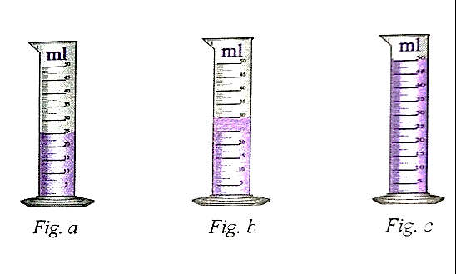Look at the picture and answer the questions.
   * + - 1. What is the volume of liquid in fig. a and c?
         2. What is the difference between the volume of liquid in fig. b and c?
         3. Which measuring cylinder has the highest volume and which one has the lowest volume of liquid?
2. How will you calculate the volume of irregular solid? Explain the process with a figure.
3. Write any four negative effects of heat.
4. Draw a well labeled diagram of parts of plants.

**The End**